SQL CLASS - 2

TOPICS – DDL Commands

SQL contains 5 sub languages –

- Data Definition Language (DDL)
- Data Manipulation Language (DML)
- Transactional Control language (TCL)
- Data Query/Retrieval Language (DQL/DRL)
- Data Control Language (DCL)

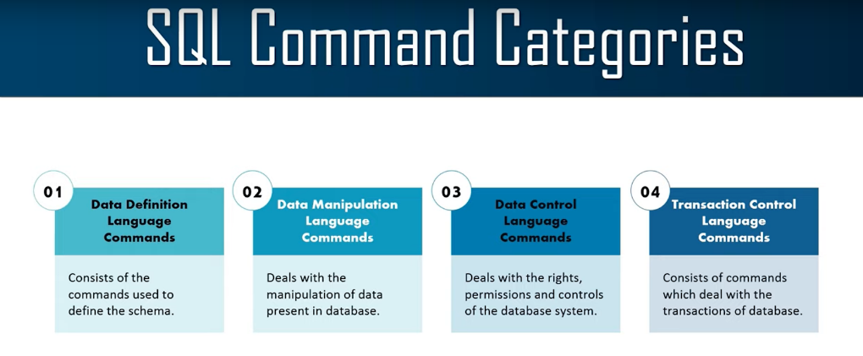

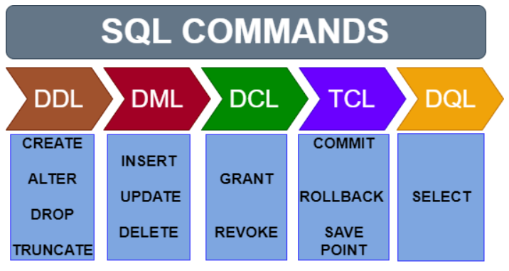

- Data definition language (DDL) - Create, Alter, Truncate, Drop, Rename

- Data Definition Language or DDL commands are used for changing the structure of an object.
- All DDL commands are auto-committed which means any changes made will be permanent in the database.

- Create - Use to create an object

Syntax - CREATE TABLE Table_Name
(First_Column_Name Data_Type,
Second_Column_Name Data_Type );

Example - CREATE TABLE studentsInfo
( StudentId NUMBER,
StudentName VARCHAR2(100),
ParentName VARCHAR2(100),
PhoneNumber NUMBER,
AddressofStudent VARCHAR2(1000),
City VARCHAR2(50),
Country VARCHAR2(50)
);

- Alter - Use to Modify the object

Add Column - Use to add column in table

Syntax - ALTER TABLE Table_Name ADD Column_Name CHAR(20);
Example - ALTER TABLE studentsInfo ADD BloodGroup CHAR(20);

Change Data Type - Use to change data type of column

Syntax - ALTER TABLE Table_Name MODIFY Column_Name Data_Type;
Example - ALTER TABLE studentsInfo MODIFY BloodGroup VARCHAR2(20);

Rename Column - Use to rename column name

Syntax - ALTER TABLE Table_Name RENAME COLUMN Old_Column_Name TO New_Column_Name;
Example - ALTER TABLE studentsInfo RENAME COLUMN BloodGroup TO BloodType;

Drop Column - Use to remove column from a table

Syntax - ALTER TABLE Table_Name DROP COLUMN Column_Name;
Example - ALTER TABLE studentsInfo DROP COLUMN BloodType;

- Truncate - Use to delete all data from table.

Syntax - TRUNCATE TABLE Table_Name;
Example - TRUNCATE TABLE studentsInfo;
INSERT INTO studentsInfo
VALUES (1, 'Amol', 'Rao', 9898989898, 'Kharadi', 'Pune', 'India');
INSERT INTO studentsInfo
VALUES (2,'Hari','Prasad', 78787878, 'Viman Nagar', 'Pune', 'India');
- Rename Table - Use to rename table

Syntax - RENAME old_table_name TO new_table_name;
Example - RENAME studentsInfo TO studentsInfo1;

- Drop - Use to remove object from database.

Syntax - DROP TABLE Table_Name;
Example - DROP TABLE studentsInfo;

To see the structure of the table then run –

Syntax - DESC/DESCRIBE Table_Name;
Example - DESCRIBE studentsInfo;
DESC studentsInfo;

Database Objects -
- An oracle database can contain multiple objects.
- The different database objects in oracle are -
Table, View, Sequence, Index, Synonym, Stored Procedures, and other database objects.

Table Restriction -
- Table can be created at any time, even when the users are using the Database.
- Size of the table need not be specified.
- To create table must specify table name, column name, data type with size
- The user should have permission for table creation.
- Table name must be unique in schema
- The Table name should begin with a letter and
- A table name size can be 1-30 characters long for oracle database version 12.1 or less and for oracle database version 12.2 and higher the maximum length of names increased to 128 bytes.
- Maximum 1000 columns are allowed in a table.
- Table name can contain: A – Z, a – z, 0 - 9, _ , $ , #
- Names cannot be duplicated for another object in the same oracle server.
- Table name cannot be oracle server reserved words.
- Table names are not case sensitive.

Column Restriction -

- The column name should begin with a letter and can be 1-30 long for oracle database version 12.1 or less and for oracle database version 12.2 and higher the maximum length of names increased to 128 bytes.
- Column name can be unique in a table.
- Maximum 1000 columns allowed in table.

__________________________THANK YOU____________________________

